Assignment-4 (SMS SPAM Classification)

- Student Name: Varshini A
- Register Number: 711519BEC117
- Team ID: PNT2022TMID07406

import numpy as np import pandas as pd
import seaborn as sns
import matplotlib.pyplot as plt

data = pd.read_csv('/content/sample_data/spam.csv',delimiter=',',encoding='latin-1') data.head()

v1 v2 Unnamed:
2
Unnamed:
3
Unnamed:
4

  - ham Go until jurong point, crazy.. Available only ... NaN NaN NaN

  - ham Ok lar... Joking wif u oni... NaN NaN NaN

  - spam Free entry in 2 a wkly comp to win FA Cup
fina...

  - ham U dun say so early hor... U c already then
say...

NaN NaN NaN

NaN NaN NaN

data.columns

Index(['v1', 'v2', 'Unnamed: 2', 'Unnamed: 3', 'Unnamed: 4'], dtype='object')

#drop the unamed columns
data=data.drop(columns=["Unnamed: 2","Unnamed: 3","Unnamed: 4"])

#rename the two relevant columns data=data.rename(
{
"v1":"Category",
"v2":"Message"
},axis=1)

data.head()

Category Message 
- ham Go until jurong point, crazy.. Available only ...

- ham Ok lar... Joking wif u oni...

- spam Free entry in 2 a wkly comp to win FA Cup fina...
#check for null values data.isnull().sum()
3 ham U dun say so early hor... U c already then say...

4 ham Nah I don't think he goes to usf, he lives aro...

Category 0
Message 0
dtype: int64

data.info()

<class 'pandas.core.frame.DataFrame'> RangeIndex: 5572 entries, 0 to 5571
Data columns (total 2 columns):
# Column Non-Null Count Dtype
- Category 5572 non-null object
- Message 5572 non-null object dtypes: object(2)
memory usage: 87.2+ KB

data["Message Length"]=data["Message"].apply(len)

fig=plt.figure(figsize=(12,8)) sns.histplot(
x=data["Message Length"], hue=data["Category"]
)
plt.title("ham & spam messege length comparision") plt.show()

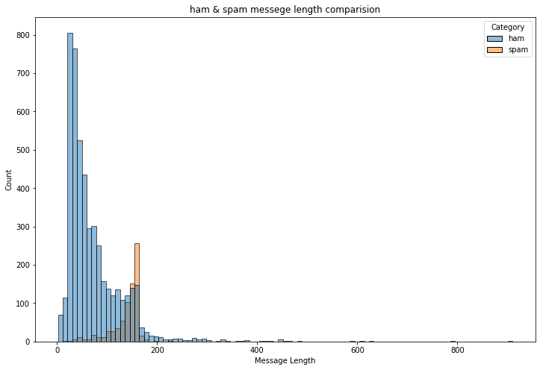#Display the description of length of ham and spam messages seperately on an individual se

ham_desc=data[data["Category"]=="ham"]["Message Length"].describe() spam_desc=data[data["Category"]=="spam"]["Message Length"].describe() print("Ham Messege Length Description:\n",ham_desc)
print("************************************")
print("Spam Message Length Description:\n",spam_desc) Ham Messege Length Description:
count | 4825.000000
mean | 71.023627
std | 58.016023
min | 2.000000
25% | 33.000000
50% | 52.000000
75% | 92.000000
max | 910.000000
Name: | Message Length, dtype: float64

************************************ Spam Message Length Description:
count | 747.000000
mean | 138.866131
std | 29.183082
min | 13.000000
25% | 132.500000
50% | 149.000000
75% | 157.000000
max | 224.000000
Name: | Message Length, dtype: float64

data.describe(include="all")

 | Category | Message | Message Length
count | 5572 | 5572 | 5572.000000
unique | 2 | 5169 | NaN

data["Category"].value_counts()
top ham Sorry, I'll call later NaN

freq 4825 30 NaN
mean NaN NaN 80.118808
std NaN NaN 59.690841
ham 4825
spam 747
Name: Category, dtype: int64
min NaN NaN 2.000000

25% NaN NaN 36.000000

50% NaN NaN 61.000000

75% NaN NaN 121.000000

max NaN NaN 910.000000
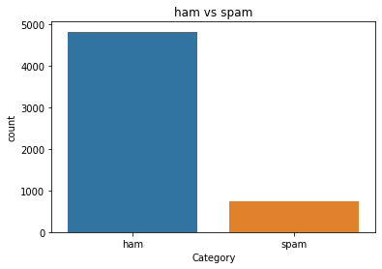
sns.countplot( data=data, x="Category"
)
plt.title("ham vs spam") plt.show()

ham_count=data["Category"].value_counts()[0] spam_count=data["Category"].value_counts()[1]

total_count=data.shape[0]

print("Ham contains:{:.2f}% of total data.".format(ham_count/total_count*100)) print("Spam contains:{:.2f}% of total data.".format(spam_count/total_count*100))

Ham contains:86.59% of total data. Spam contains:13.41% of total data.

#compute the length of majority & minority class minority_len=len(data[data["Category"]=="spam"]) majority_len=len(data[data["Category"]=="ham"])

#store the indices of majority and minority class
minority_indices=data[data["Category"]=="spam"].index majority_indices=data[data["Category"]=="ham"].index

#generate new majority indices from the total majority_indices
#with size equal to minority class length so we obtain equivalent number of indices length random_majority_indices=np.random.choice(
majority_indices, size=minority_len, replace=False
)

#concatenate the two indices to obtain indices of new dataframe
undersampled_indices=np.concatenate([minority_indices,random_majority_indices])

#create df using new indices
df=data.loc[undersampled_indices]

#shuffle the sample df=df.sample(frac=1)

#reset the index as its all mixed df=df.reset_index()

#drop the older index df=df.drop(
columns=["index"],
)

df.shape

(1494, 3)
df["Category"].value_counts() ham 747
spam 747
Name: Category, dtype: int64

sns.countplot( data=df,
x="Category"
)
plt.title("ham vs spam") plt.show()

Category | Message | Message | Length
0 ham | Aah! A cuddle would be lush! I'd need lots of ... |  | 87
1 ham | I'm in solihull, | do you want anything? |  | 40
2 spam | Double Mins & 1000 txts on Orange tariffs. Lat... |  | 151
3 ham | No we put party 7 days a week and study lightl... |  | 126
4 spam | URGENT!! Your 4* Costa Del Sol Holiday or å£50... |  | 161

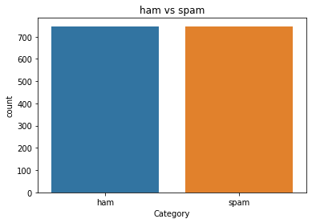#Created new column Label and encode ham as 0 and spam as 1 df["Label"]=df["Category"].map(
df.head()
{
"ham":0,
"spam":1
}
)

df.head()

Category | Message | Message | Length | Label
0 ham | Aah! A cuddle would be lush! I'd need lots of ... |  | 87 | 0
1 ham | I'm in solihull, | do you want anything? |  | 40 | 0
2 spam | Double Mins & 1000 txts on Orange tariffs. Lat... |  | 151 | 1
3 ham | No we put party 7 days a week and study lightl... |  | 126 | 0
4 spam | URGENT!! Your 4* Costa Del Sol Holiday or å£50... |  | 161 | 1

import re
import nltk
from nltk.corpus import stopwords from nltk.stem import PorterStemmer

stemmer=PorterStemmer()

nltk.download('stopwords')

[nltk_data] Downloading package stopwords to /root/nltk_data... [nltk_data] Unzipping corpora/stopwords.zip.
True

#declare empty list to store tokenized message corpus=[]

#iterate through the df["Message"] for message in df["Message"]:

#replace every special characters, numbers etc.. with whitespace of message #It will help retain only letter/alphabets
message=re.sub("[^a-zA-Z]"," ",message)

#convert every letters to its lowercase message=message.lower()

#split the word into individual word list message=message.split()

#perform stemming using PorterStemmer for all non-english-stopwords message=[stemmer.stem(words)
for words in message
if words not in set(stopwords.words("english"))
]
#join the word lists with the whitespace message=" ".join(message)

#append the message in corpus list corpus.append(message)

from tensorflow.keras.preprocessing.text import one_hot vocab_size=10000

oneHot_doc=[one_hot(words,n=vocab_size) for words in corpus
]

df["Message Length"].describe()

count | 1494.000000
mean | 105.203481
std | 61.166448
min | 3.000000
25% | 48.000000
50% | 118.000000
75% | 153.000000
max  Name: | 790.000000  Message Length, dtype: | float64

fig=plt.figure(figsize=(12,8)) sns.kdeplot(
x=df["Message Length"], hue=df["Category"]
)

plt.title("ham & spam messege length comparision") plt.show()
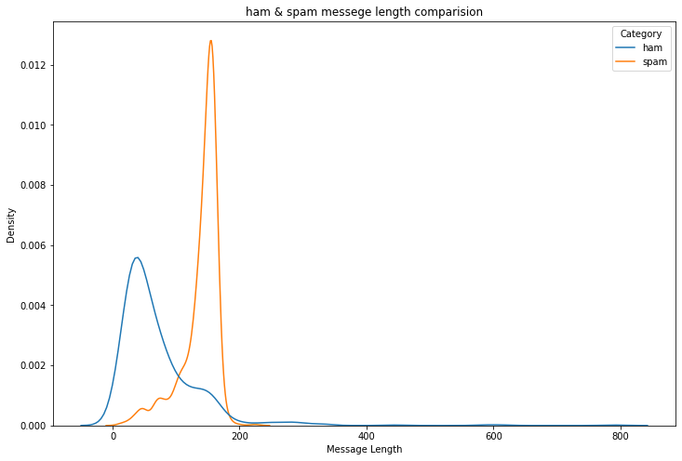

from tensorflow.keras.preprocessing.sequence import pad_sequences sentence_len=200
embedded_doc=pad_sequences( oneHot_doc,
maxlen=sentence_len, padding="pre"
)

extract_features=pd.DataFrame( data=embedded_doc
)
target=df["Label"]

df_final=pd.concat([extract_features,target],axis=1)

df_final.head()

0 | 1 | 2 | 3 | 4 | 5 | 6 | 7 | 8 | 9 ... 191 | 192 | 193 | 194 | 195 | 196 | 197 | 198
0 0 | 0 | 0 | 0 | 0 | 0 | 0 | 0 | 0 | 0 ... 2090 | 1632 | 4289 | 7158 | 478 | 5808 | 6133 | 8348
1 0 | 0 | 0 | 0 | 0 | 0 | 0 | 0 | 0 | 0 ... 0 | 0 | 0 | 0 | 0 | 0 | 8663 | 4425

X=df_final.drop("Label",axis=1) y=df_final["Label"]
2 0 0 0 0 0 0 0 0 0 0 ... 1275 702 1694 4114 4162 3935 4162 8536

3 0 0 0 0 0 0 0 0 0 0 ... 3705 9946 5462 7158 9883 4500 8030 8630
4 0 0 0 0 0 0 0 0 0 0 ... 4753 6414 5018 1953 216 1175 8861 2485
5 rows × 201 columns
from sklearn.model_selection import train_test_split

X_trainval,X_test,y_trainval,y_test=train_test_split( X,
y,
random_state=42, test_size=0.15
)

X_train,X_val,y_train,y_val=train_test_split( X_trainval,
y_trainval,
random_state=42, test_size=0.15
)

from tensorflow.keras.layers import LSTM from tensorflow.keras.layers import Dense
from tensorflow.keras.layers import Embedding from tensorflow.keras.models import Sequential model=Sequential()

feature_num=100 model.add(
Embedding(
input_dim=vocab_size, output_dim=feature_num,
input_length=sentence_len
)
)
model.add(
LSTM(
units=128
)
)

model.add(
Dense(
units=1,
activation="sigmoid"
)
)

from tensorflow.keras.optimizers import Adam model.compile(
optimizer=Adam(
learning_rate=0.001
),
loss="binary_crossentropy", metrics=["accuracy"]
)

model.fit(
X_train, y_train,
validation_data=( X_val,
y_val
),
epochs=10
)

Epoch | 1/10
34/34  Epoch 34/34 | [==============================] 2/10  [==============================] | - 8s  - 1s | 33ms/step  16ms/step | - loss:  - loss: | 0.5258  0.1718 | - accuracy:  - accuracy: | 0.7  0.9
Epoch  34/34 | 3/10  [==============================] | - 1s | 16ms/step | - loss: | 0.0533 | - accuracy: | 0.9
Epoch | 4/10
34/34  Epoch 34/34 | [==============================] 5/10  [==============================] | - 1s  - 1s | 15ms/step  16ms/step | - loss:  - loss: | 0.0254  0.0184 | - accuracy:  - accuracy: | 0.9  0.9
Epoch 34/34 | 6/10  [==============================] | - 1s | 16ms/step | - loss: | 0.0134 | - accuracy: | 0.9
Epoch  34/34 | 7/10  [==============================] | - 1s | 16ms/step | - loss: | 0.0150 | - accuracy: | 0.9
Epoch | 8/10
34/34  Epoch 34/34 | [==============================] 9/10  [==============================] | - 1s  - 1s | 16ms/step  16ms/step | - loss:  - loss: | 0.0112  0.0062 | - accuracy:  - accuracy: | 0.9  0.9
Epoch  34/34 | 10/10  [==============================] | - 1s | 16ms/step | - loss: | 0.0050 | - accuracy: | 0.9
<keras.callbacks.History at 0x7fa3263a7850>

y_pred=model.predict(X_test) y_pred=(y_pred>0.5)

8/8 [==============================] - 0s 8ms/step

from sklearn.metrics import accuracy_score,confusion_matrix

score=accuracy_score(y_test,y_pred)
print("Test Score:{:.2f}%".format(score*100))

Test Score:96.00%

cm=confusion_matrix(y_test,y_pred) fig=plt.figure(figsize=(12,8))
sns.heatmap( cm,
annot=True,
)
plt.title("Confusion Matrix") cm

array([[100, 2],
[ 7, 116]])
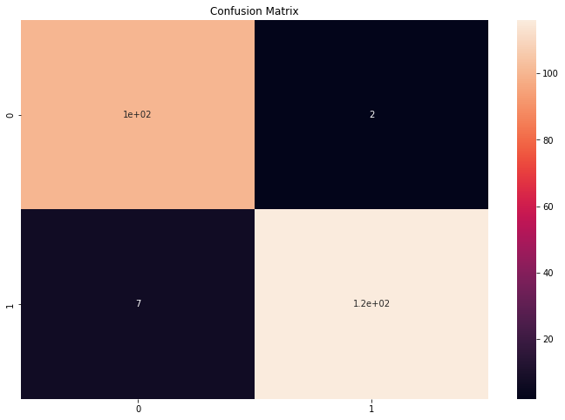

#The function take model and message as parameter def classify_message(model,message):

#We will treat message as a paragraphs containing multiple sentences(lines) #we will extract individual lines
for sentences in message:
sentences=nltk.sent_tokenize(message)

#Iterate over individual sentences for sentence in sentences:
#replace all special characters
words=re.sub("[^a-zA-Z]"," ",sentence)

#perform word tokenization of all non-english-stopwords if words not in set(stopwords.words('english')):

word=nltk.word_tokenize(words) word=" ".join(word)

#perform one_hot on tokenized word oneHot=[one_hot(word,n=vocab_size)]

#create an embedded documnet using pad_sequences #this can be fed to our model
text=pad_sequences(oneHot,maxlen=sentence_len,padding="pre")

#predict the text using model predict=model.predict(text)

#if predict value is greater than 0.5 its a spam if predict>0.5:
print("It is a spam")
#else the message is not a spam else:
print("It is not a spam")

message1="I am having a bad day and I would like to have a break today"
message2="This is to inform you had won a lottery and the subscription will end in a week

nltk.download('punkt')

[nltk_data] Downloading package punkt to /root/nltk_data... [nltk_data] Unzipping tokenizers/punkt.zip.
True

classify_message(model,message1)

1/1 [==============================] - 0s 21ms/step
It is not a spam

classify_message(model,message2)

1/1 [==============================] - 0s 22ms/step
It is a spam

Colab paid products - Cancel contracts here 0s completed at 8:07 AM

